

M.V.P. SAMAJ’S

K.R.T ARTS, A.M.SCIENCE AND B.H.COMMERCE

COLLEGE, GANGAPUR ROAD

NASHIK.

**A PROJECT REPORT**

**ON**

**Online Bakery Management System**

**Developed by**

Dubey Anant Jitendra

Gangurde Sukrut Sunil

Gaikwad Punam Himmatrao

Deore Harshada Vinaykumar

B.Sc. (Computer Science)

(2021-2022)

Under the guidance of

Prof. B.B. Darekar

Department of Computer Science



M.V.P.SAMAJ’S

K.R.T ARTS, A.M.SCIENCE AND B.H.COMMERCE

COLLEGE, GANGAPUR ROAD

NASHIK.

**CERTIFICATE**

*This is to certify that project report on*

*Online Bakery Management System*

*Has been successfully completed by,*

**Dubey Anant Jitendra**

**Gangurde Sukrut Sunil**

**Gaikwad Punam Himmatrao**

**Deore Harshada Vinaykumar**

*For fulfillment of T.Y.B.Sc (Computer Science)*

*During the academic year 2021-2022*

*(Prof. B. B. Darekar) (Dr. M. N. Shelar)*

*Project Guide Head of Department External Examiner*

**Acknowledgement**

*We would like to express our special thanks of gratitude to our project guide* ***Prof. B.B. Darekar****, our Computer Science Head of Department* ***Dr. M. N. Shelar*** *as well as our principal* ***Dr. V. B. Gaikwad*** *who gave us the golden opportunity to do this wonderful project of* ***Bakersvilla*** *on the topic* ***Online Bakery Management System****, which also helped us in doing a lot of Research and we came to know about so many new things.*

*This project is substantially upgrading our skill of software development which we intend to good use in developing better system in future.*

*In conclusion, we would like to express our thanks to* ***management of K.T.H.M. College, Nashik*** *for providing us all the facilities which helped in completion of our project.*

*Finally, we extend our thanks to all* ***B.Sc. (Computer Science) staff****, Classmates and also thanks to* ***our parents*** *to help us all the time.*

*And special thanks to* ***our Friends*** *who helped us, they pointed out errors & suggested changes, which in turn helped in many ways.*

*Thank you all.*

*Dubey Anant Jitendra*

*Gangurde Sukrut Sunil*

*Gaikwad Punam Himmatrao*

*Deore Harshada Vinaykumar*

Table of Contents

**1.** **Abstract** 1

**2.** **Introduction** 2

**3.** **Problem Definition** 4

**4.** **Need Of System** 5

**5.** **Proposed System** 6

**6.** **Feasibility Study** 7

**1.** **Operational Feasibility: -** 7

**2.** **Technical Feasibility: -** 7

**3.** **Economic Feasibility: -** 7

**7.** **Tools & Technologies Used** 8

**1.** **Languages** 8

1.1. PostgreSQL 8

1.2. PHP 8

1.3. HTML 9

1.4. CSS 10

1.5. JS 10

**2.** **Software** 11

2.1. VS Code 11

2.2. Chrome 12

2.3. Git & Github 13

**8.** **Hardware & Software Requirements** 15

**9.** **Modules** 16

**10.** **Fact Finding Techniques** 18

**1.** **Interviewing: -** 18

**2.** **Record Review: -** 18

**3.** **Observation: -** 19

**11.** **E-R Diagram** 20

**12.** **UML Diagrams** 21

**1.** **Class Diagram** 21

**2.** **Use-case Diagram** 22

**3.** **Sequence Diagram for User** 23

**4.** **Sequence Diagram for Admin/Shopkeeper** 24

**5.** **Activity Diagram for User** 25

**6.** **Activity Diagram for Admin/Shopkeeper** 26

**7.** **Component Diagram** 27

**8.** **Deployment Diagram** 28

**13.** **Data Dictionary** 29

**14.** **Conclusion** 31

**15.** **Advantages** 32

**16.** **Disadvantages** 32

**17.** **Applications** 32

**18.** **Bibliography** 33

# **Abstract**

Online shopping is becoming trend nowadays. People like online shopping compared to the traditional way to save their money and time. BakersVilla is an online bakery ordering system where various types of cakes are the main product to sell online. We are aiming to develop a web based online bakery system as well as order status notification and verify of customer's status of registration.

There are three main users for the system which are registered customer, non-registered customer and administrator. Registered customers have more privilege in the system compared to non-registered customers as they able to purchase the product online.

# **Introduction**

This project is an online bakery shop that allows users to check for different bakery items available at the online shop and then purchase online. The project provides a list of bakery products displayed online in various categories. The user may browse through these items. If the user wants to purchase any product(s), he/she may add it to his shopping cart.

Keeping the features of an e-commerce site, an online bakery shop software project acts as a central database containing various bakery products. It provides customers online shopping facilities from their homes. Usually, the customer will be asked to fill a very short and simple form containing information about shipping address and other details, etc.

A customer can sign up for free, log in to his / her account can browse items of his / her own interest, and can view prices and other details of selected items, place items into the shopping cart. After that, the user can check out. At checkout time, the items and the total amount to be paid presented as a ready order to the customer.

This website project will be developed using PHP as the front end and SQL Server as a back-end. The SQL database will store all information about the users and various bakery items along with their respective categories.

Once the user makes a successful transaction, they get a copy of the shopping receipt on their email id. Customer should order at least 24 hrs. before, so that the product they want will be available in our stock. Doorstep deliver is available and also midnight delivery is available.

**Functional Requirements:**

* 1. The system shall provide a convenient interface for User Registration, Categories and Items Search.
  2. A guest user must login to view items.
  3. The system should be able to show bakery products in their respective categories.
  4. The system shall be capable to generate invoice bill and the Customer shall be able to pay it online.
  5. If an item is not available (out of stock), and a customer selects it, an alert should be shown to the customer that this item is out of stock. Managing your stock efficiently is required for this task.
  6. The systems shall have both admin and customer views. i.e. Administrator View and User View.

**Tools:**SQL, PHP, HTML, CSS, JS

# **Problem Definition**

Customers visits Bakery shops physically which requires an ample amount of time which reduces the efficiency of the sales and increase hassle which is faced by customers as well as staff of the bakery.

Online bakery solves that problem for everyone who has a device which supports a web browser and have an internet connection. Manually managing bakery is difficult and requires a lot of skill whereas operating a website can be done by anyone who have some knowledge of website. With the help of online bakery management system, it becomes easier and faster to manage the whole system.

Shopkeeper has to invest a large amount of money to build a bakery before they can start selling their product and make some profit, Online bakery management system solves this problem for the shopkeeper as they now don’t have to invest all that money beforehand and they can start selling on the go.

As online websites and systems are getting an increase in popularity in this modern era the shopkeeper and customer will find it much easier and relaxing to use this online system and get what they want without much difficulty.

# **Need Of System**

The online system was needed because of the following drawbacks in the present manual system.

* Keeping a record of all customers was a very tedious job.
* Searching a particular record was tedious because it involved searching all entries which required more time.
* Fine manipulation of records is done automatically in computerized system unlike manual system thus eliminating the chance of error.
* Manual system is difficult and time consuming.
* Due to computerization, data storage and retrieval is done efficiently.
* Human errors are reduced.
* Makes system user friendly.
* Current records can be matched with the previous records which improves management of records.
* When searching a product, customer can always search for the best deal available thus benefitting customer.

# **Proposed System**

This system provides an interactive interface through which a user can interact with different areas of application easily.

Authorization system of an online system is one of important feature without an effective authorization mechanism.

Searching products is more convenient.

Our system maintains the information of customer such as customer Id, customer name, Email.

Our system also maintains the information of products such as product details, product price, and quantity.

System provides an interface to shopkeeper to sell his products without an extra cost.

# **Feasibility Study**

An important outcome of preliminary investigation is the determination that the requested system is feasible for organization or not.

There are three aspects of Feasibility Study are as follows:

## **Operational Feasibility: -**

The present system is easily understandable the users are presented with friendly user interface that helps them to understand the flow of the system more easily. Maximum Transparency has been provided. The new system is very much user friendly and operational cost is of the new system needs fewer human efforts. The proposed project is beneficial to the organizational and is user friendly. The system is directly used by the users and needs no other operators to coordinate the system. So, the system can be judged operationally feasible.

## **Technical Feasibility: -**

Whether it is possible to develop the project with available equipment as well as available Software and Hardware with available manpower. If there will be any kind of need in order to develop the software in this phase the cost of hardware, software as well as technical equipment are considered and found that whether requested system is technically feasible for the organization or not.

## **Economic Feasibility: -**

The presence of hardware, software and various technical equipment reduced our cost as compared to the total work for the system. Hence the system being economically feasible.

# **Tools & Technologies Used**

## **Languages**

### PostgreSQL

PostgreSQL (pronounced as **post-gress-Q-L**) is an open-source relational database management system (DBMS) developed by a worldwide team of volunteers. PostgreSQL is not controlled by any corporation or other private entity and the source code is available free of charge.

PostgreSQL runs on all major operating systems, including Linux, UNIX (AIX, BSD, HP-UX, SGI IRIX, Mac OS X, Solaris, Tru64), and Windows. It supports text, images, sounds, and video, and includes programming interfaces for C / C++, Java, Perl, Python, Ruby, Tcl and Open Database Connectivity (ODBC). 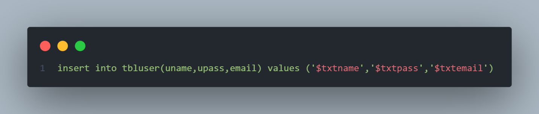

A simple PostgreSQL query

### PHP

PHP is an acronym for "PHP: **Hypertext Preprocessor**". It is a widely-used, open-source scripting language. PHP scripts are executed on the server and it is free to download and use.

PHP files can contain text, HTML, CSS, JavaScript, and PHP code. It is executed on the server, and the result is returned to the browser as plain HTML. PHP generates dynamic page content and can create, open, read, write, delete, and close files on the server. PHP can also send and receive cookies and can add, delete, modify data in your database

PHP runs on various platforms (Windows, Linux, Unix, Mac OS X, etc.). PHP is compatible with almost all servers used today (Apache, IIS, etc.)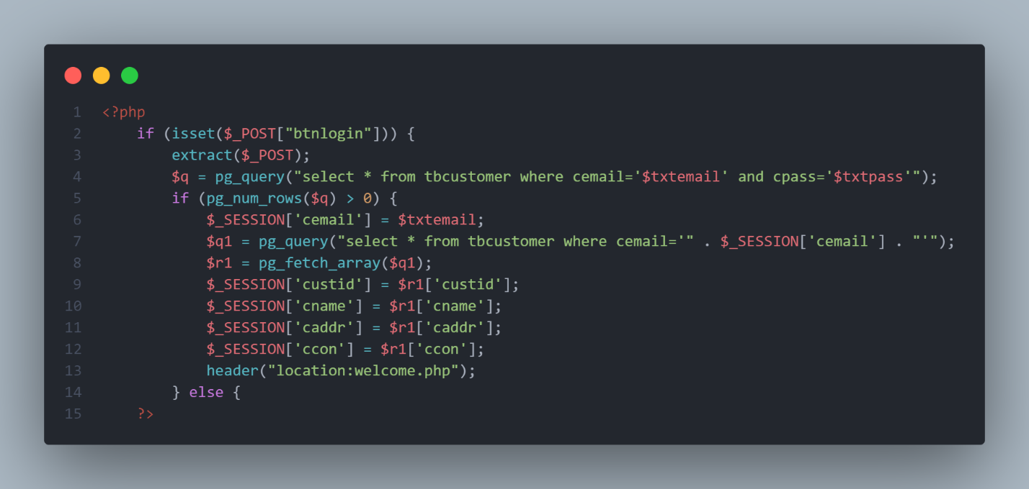

A PHP code snippet from Bakersvilla website

### HTML

HTML, or **HyperText Markup Language**, allows web users to create and structure sections, paragraphs, and links using elements, tags, and attributes. However, it’s worth noting that HTML is not considered a programming language as it can’t create dynamic functionality.

HTML has a lot of use cases, namely: Web development, Web documentation, Internet navigation, etc.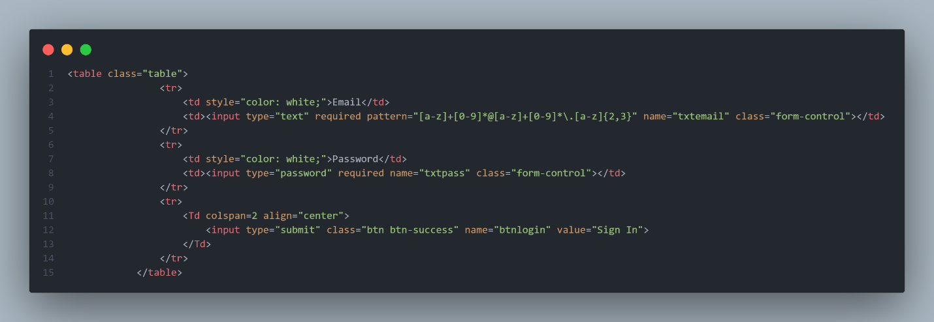

A HTML code snippet from Bakersvilla website

### CSS

**Cascading Style Sheets** (CSS) is a stylesheet language used to describe the presentation of a document written in HTML or XML. CSS describes how elements should be rendered on screen.

CSS is among the core languages of the open web and is standardized across Web browsers.

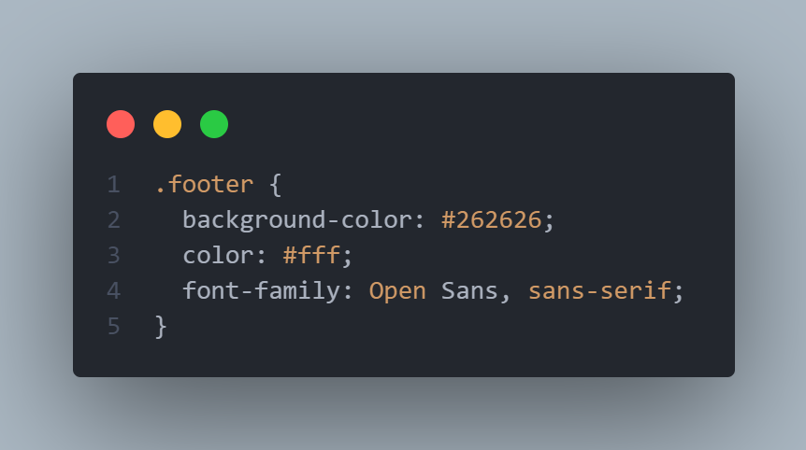

A CSS code snippet from Bakersvilla website

### JS

**JavaScript** (often shortened to JS) is a lightweight, interpreted, object-oriented language with first-class functions, and is best known as the scripting language for Web pages, but it's used in many non-browser environments as well.

JavaScript runs on the client side of the web, which can be used to design / program how the web pages behave on the occurrence of an event.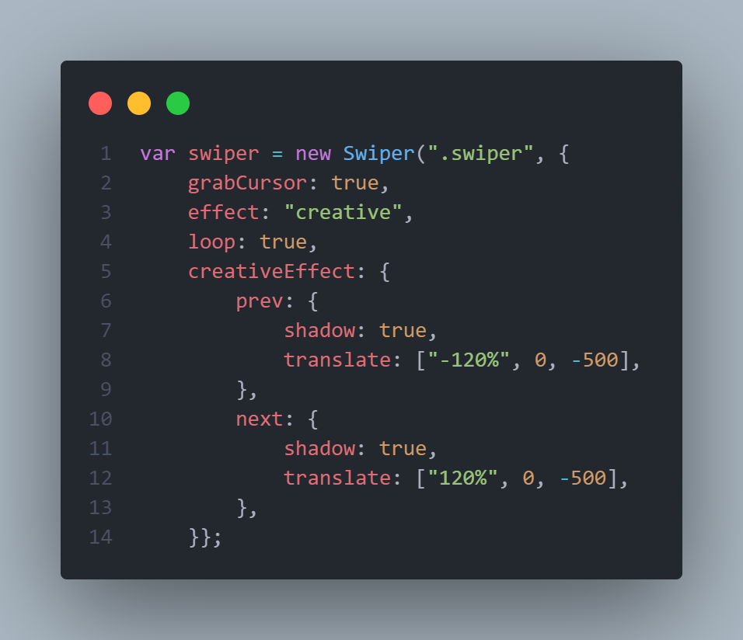

A JS code snippet from Bakersvilla website

## **Software**



### VS Code

Visual Studio Code is a lightweight but powerful source code editor which runs on your desktop and is available for Windows, macOS and Linux. It comes with built-in support for JavaScript, TypeScript and Node.js and has a rich ecosystem of extensions for other languages (such as C++, C#, Java, Python, PHP, Go). 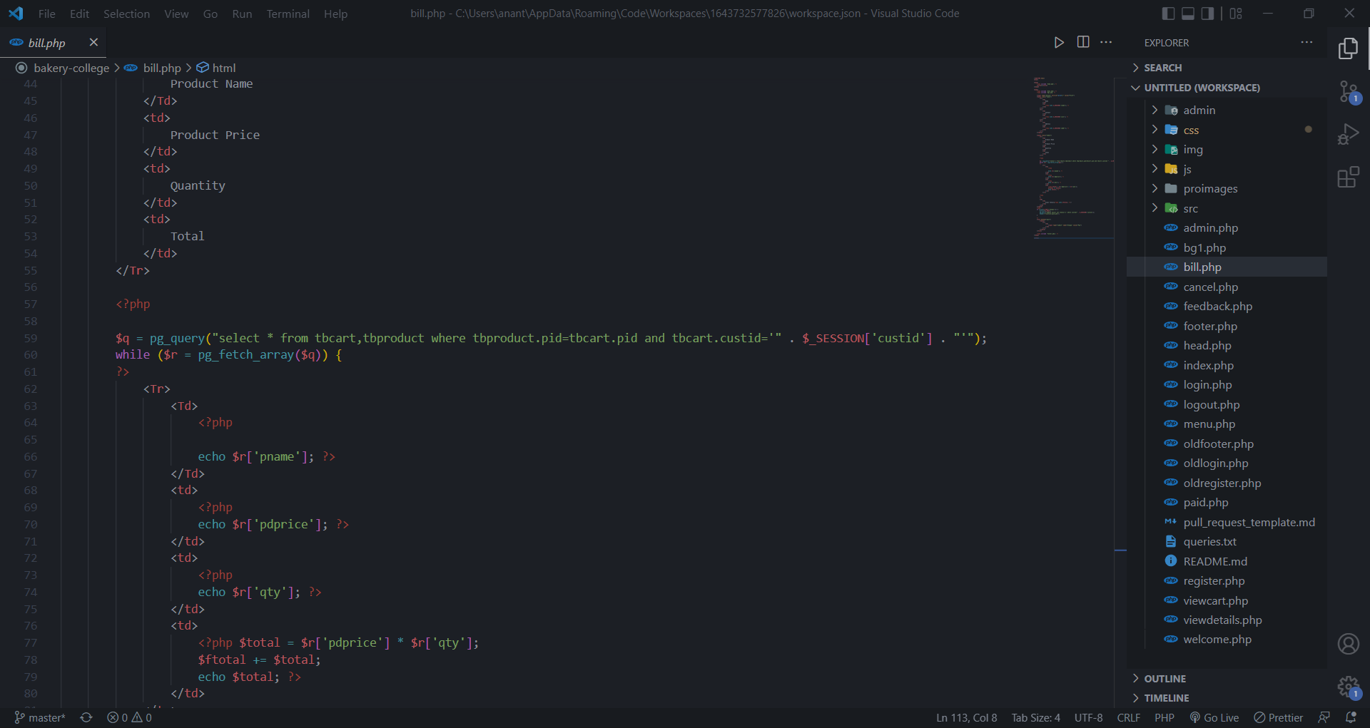

Snapshot of Visual Studio Code working environment

### Chrome

Chrome, an Internet browser released by Google, Inc., a major American search engine company, in 2008. By 2013 Chrome had become the dominant browser. Chrome is based on the open-source code of the Chromium project, but Chrome itself is not open-source.

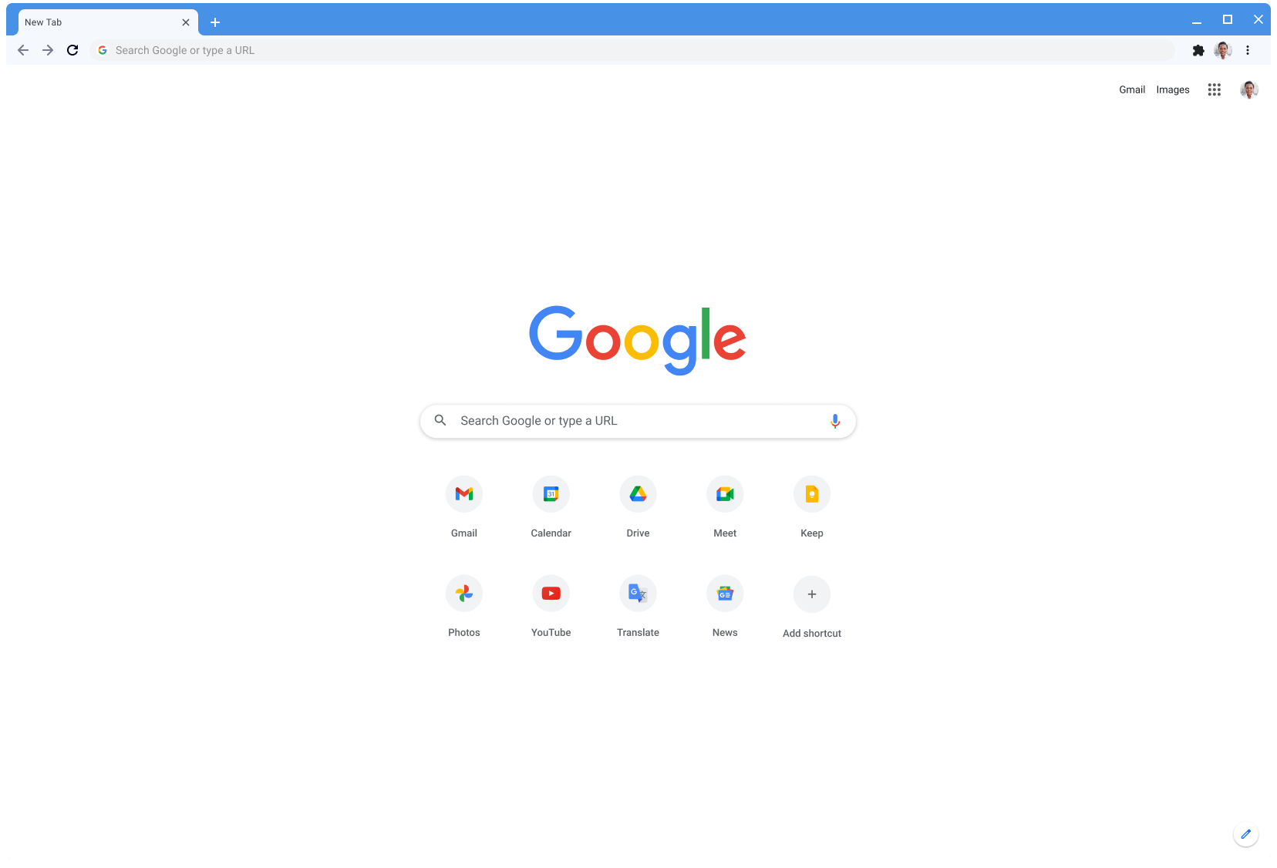

Snapshot of Chrome working environment

### Git & Github

Git is a version control tool (software) to track the changes in the source code. GitHub is a web-based cloud service to host your source code (Git repositories). It is a centralized system.

Combined they both used to keep track of source code file and helps project synchronization among teammates.

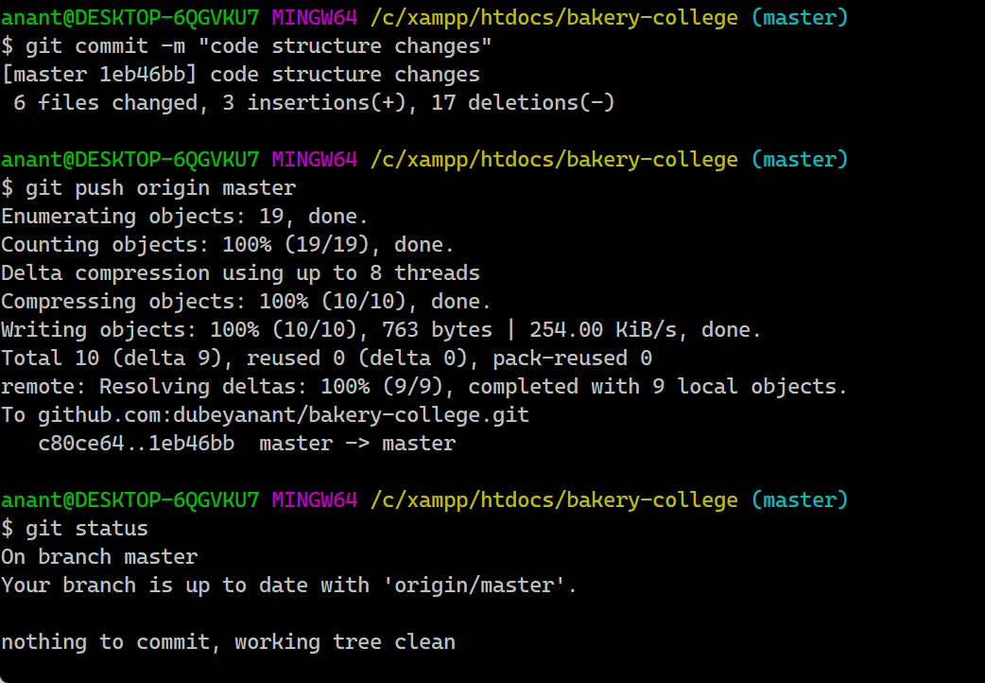

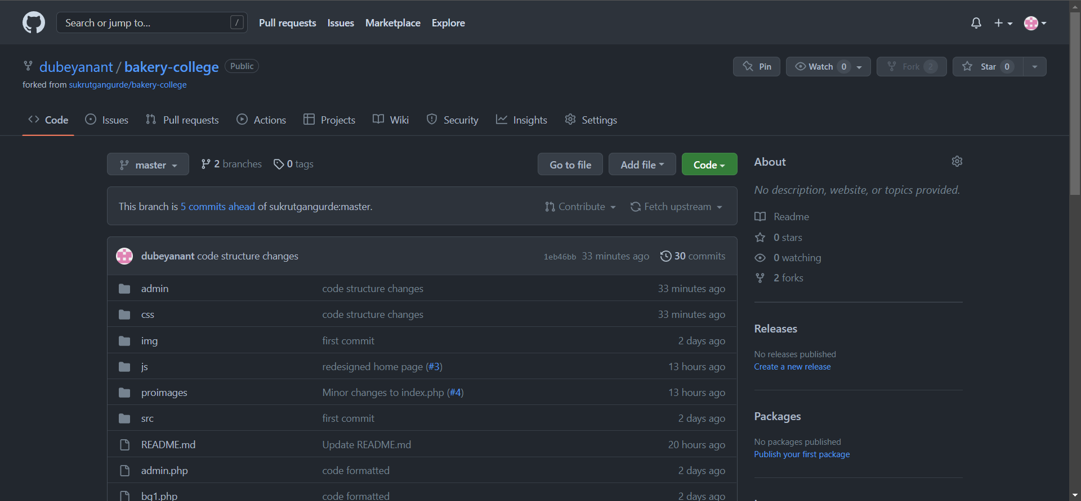

# **Hardware & Software Requirements**

|  |  |
| --- | --- |
| Processor | Intel i3 8th Gen or Ryzen 3 |
| RAM | 4 GB |
| Storage | No storage is required as this is an online website |
| Operating System | Windows, Linux, Mac OS |

# **Modules**

* **User Registration**: User can register on the system and get his online account on site.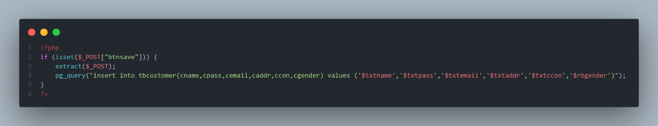
* **User Login**: User can login to system and check various bakery items.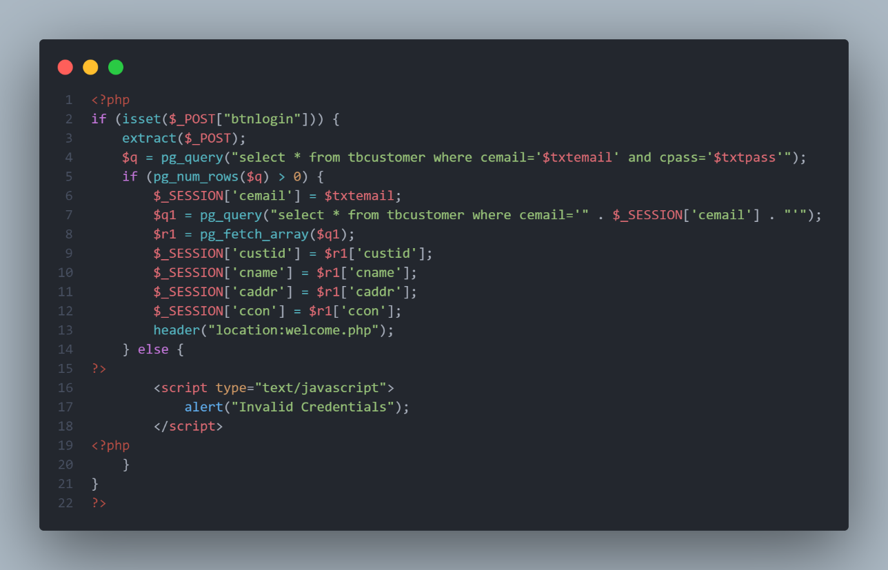
* **Product Categories**: The bakery products are arranged and can be viewed in categories.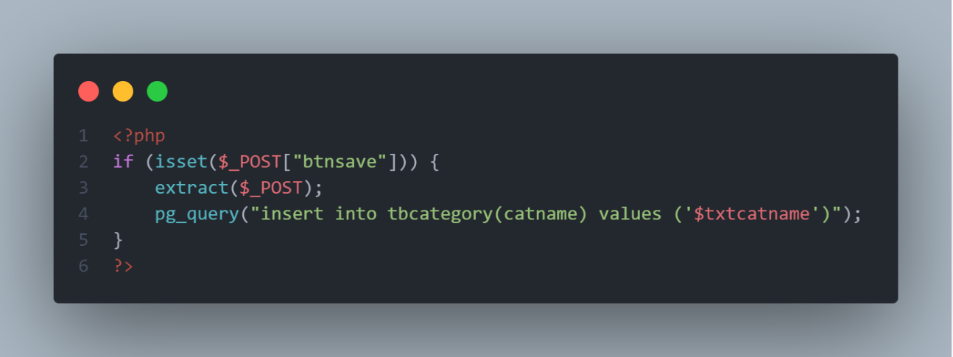
* **Add to cart**: Users can add new items to cart.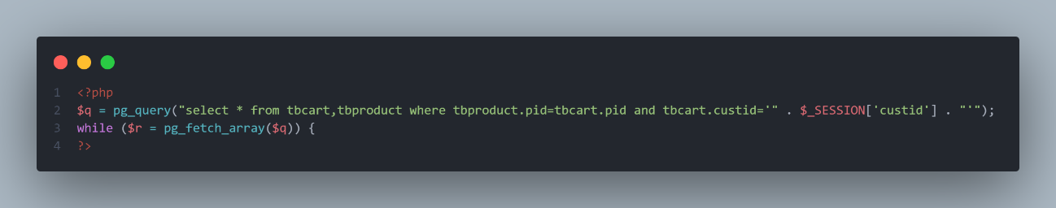

# **Fact Finding Techniques**

At the time of the analysis of the system or before starting actual work of system the system analyst has to collect information about the manual system from the user department for which the system is going to be developed. In order to collect this information, system analyst prefers anyone of the following fact-finding technique or prefers two or more fact finding techniques according to situation: -

1. Interview
2. Record Review
3. Observation

## **Interviewing: -**

System investigation has been done, by taking interview of the concerned person, higher officials & users. By asking then about manual process, problems regarding system, they requirements, any they’re valuable suggestions and guidance regarding the system.

After taking their interviews regarding the system and studying pointes crucial for system, and for any further need, inter – views were taken again & the pointes were discussed & covered which previously ware not understood. This interview technique proved beneficial regarding preliminary investigation but requires much time than the other techniques.

## **Record Review: -**

This technique proves in finding facts of system and pointes must be covered while designing the current system. Observing documents, register and files, which are prepared manually by the department, carries out the technique of record review. It helps the design of inputs and output required for the system, the database, screen –designing etc. Thus, this technique proves very helpful for analyzing about the system.

## **Observation: -**

Observation allows analyst to gain information, they cannot be obtained by any other technique through its analyst can obtain first and observation about how activities are carried out.

# **E-R Diagram**

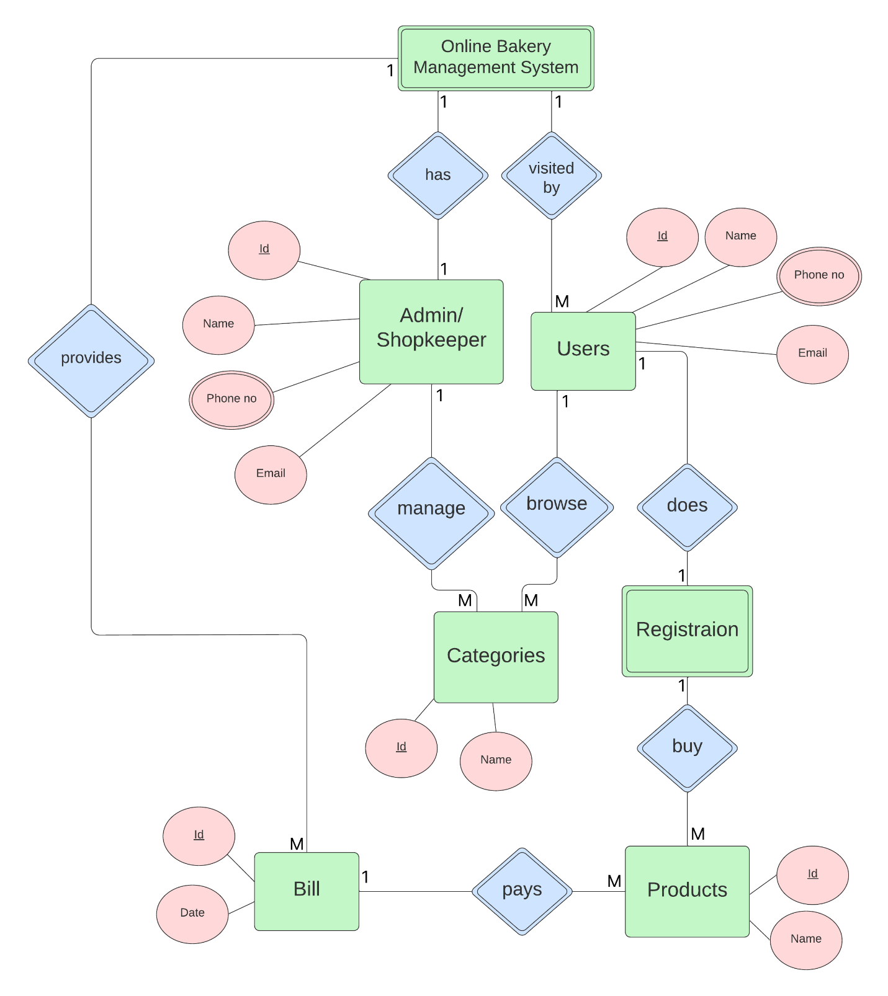

# **UML Diagrams**

## **Class Diagram**

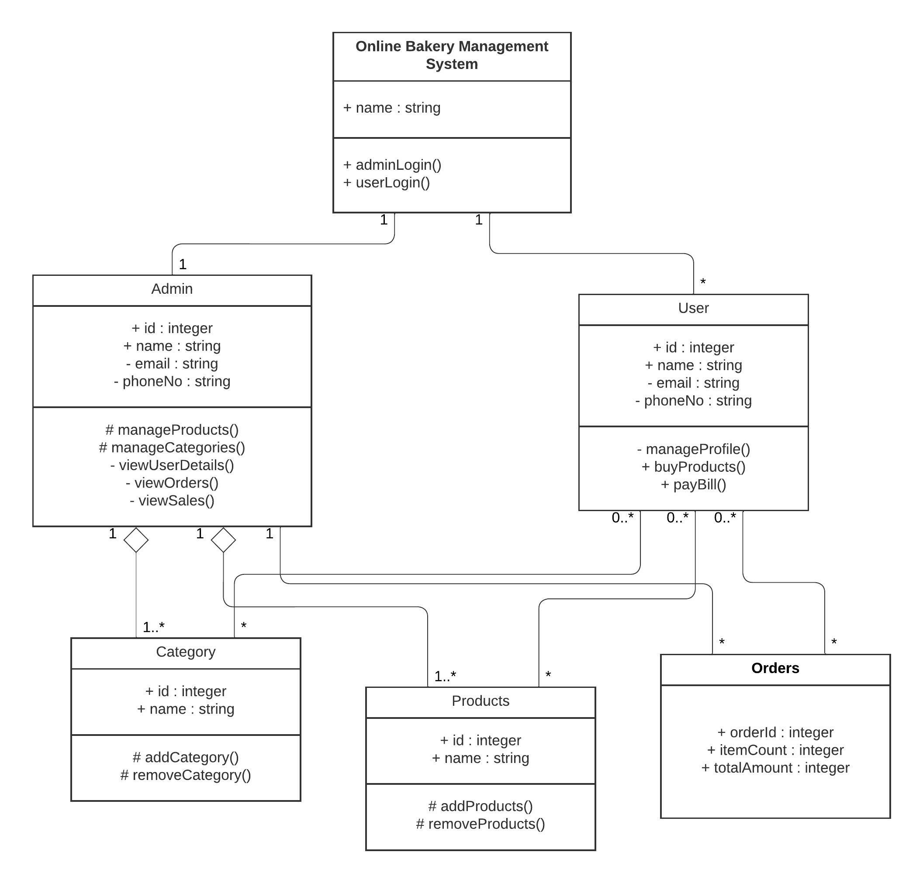

## **Use-case Diagram**

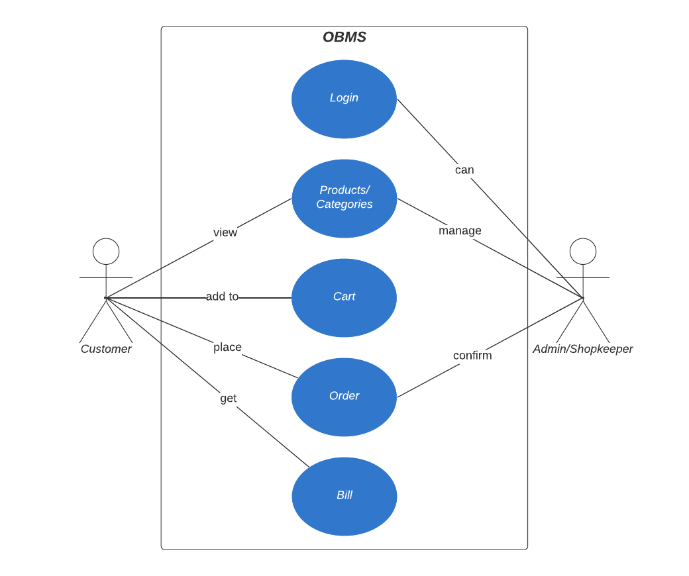

## **Sequence Diagram for User**

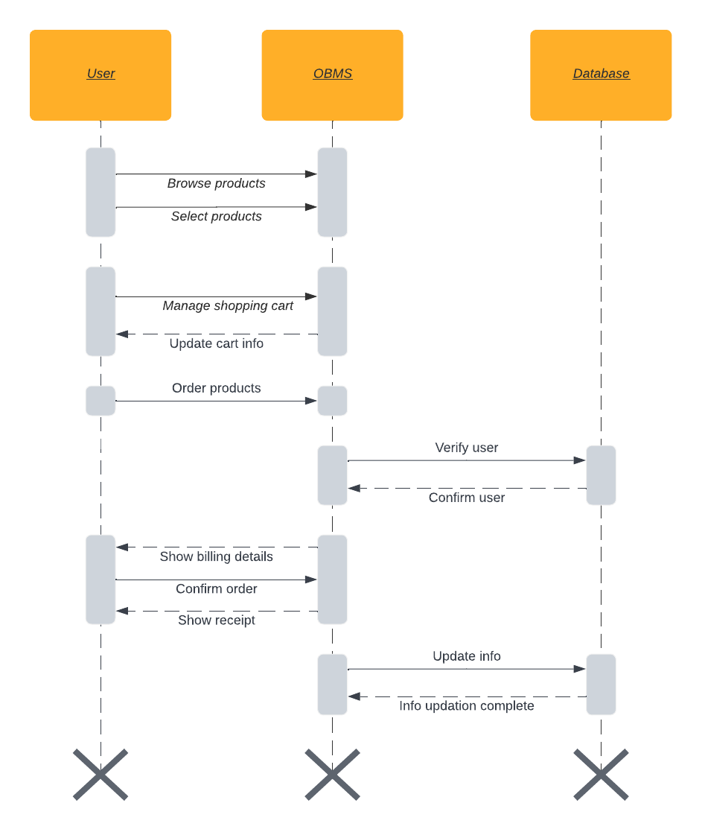

## **Sequence Diagram for Admin/Shopkeeper**

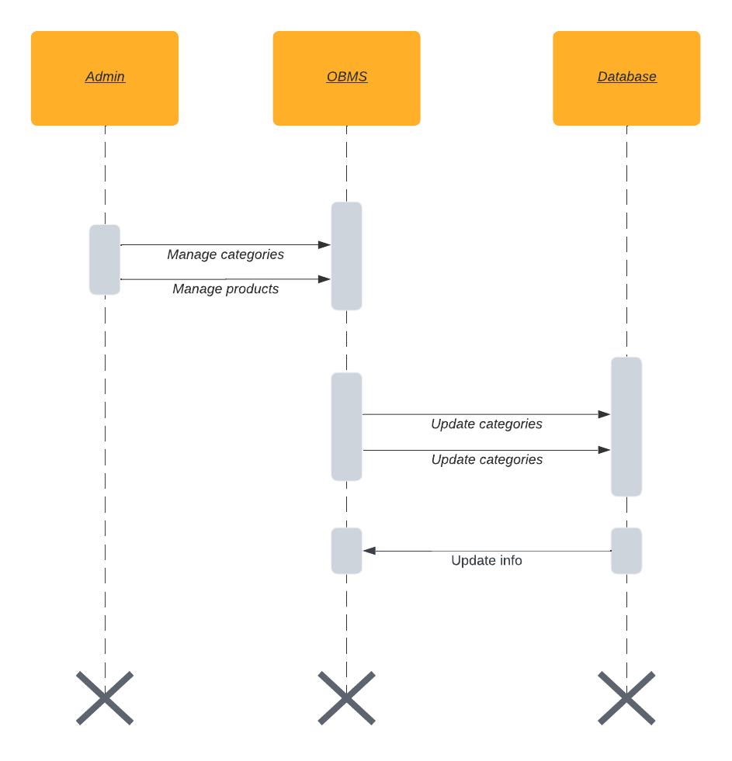

## **Activity Diagram for User**

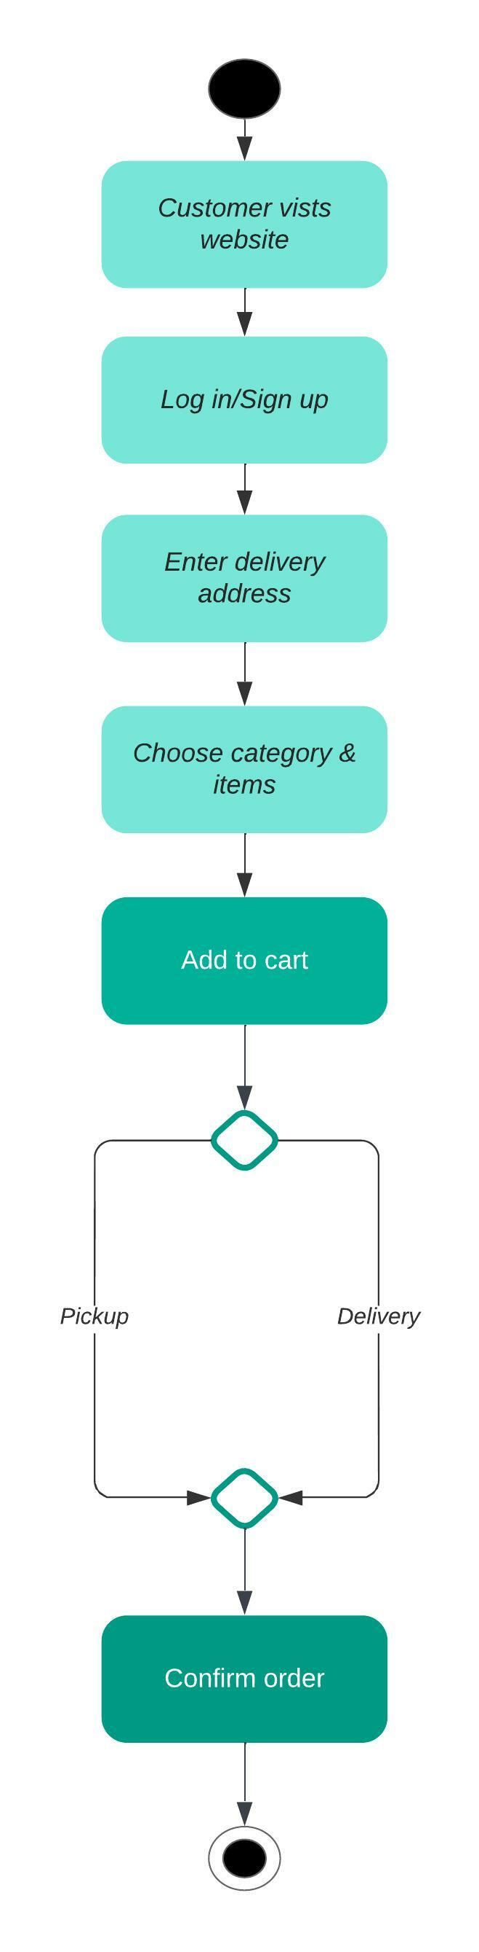

## **Activity Diagram for Admin/Shopkeeper**

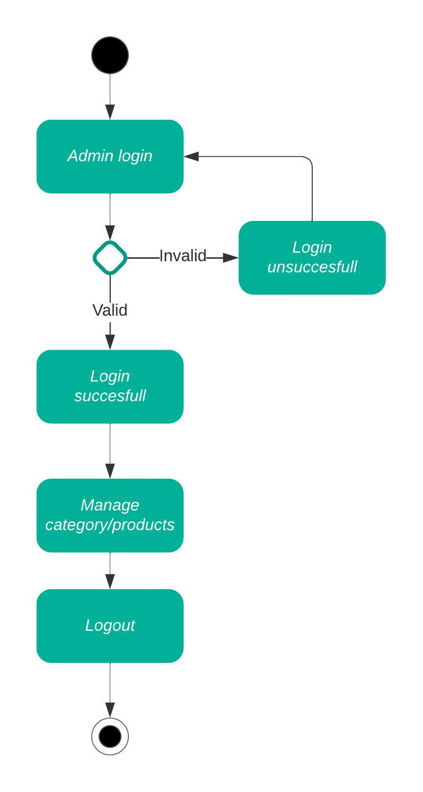

## **Component Diagram**

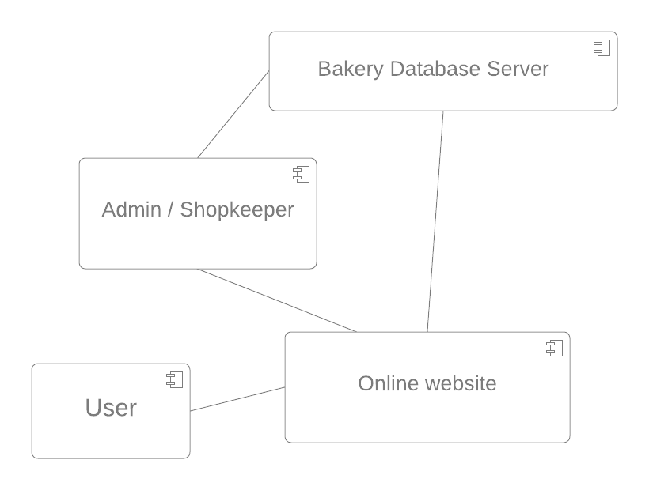

## **Deployment Diagram**

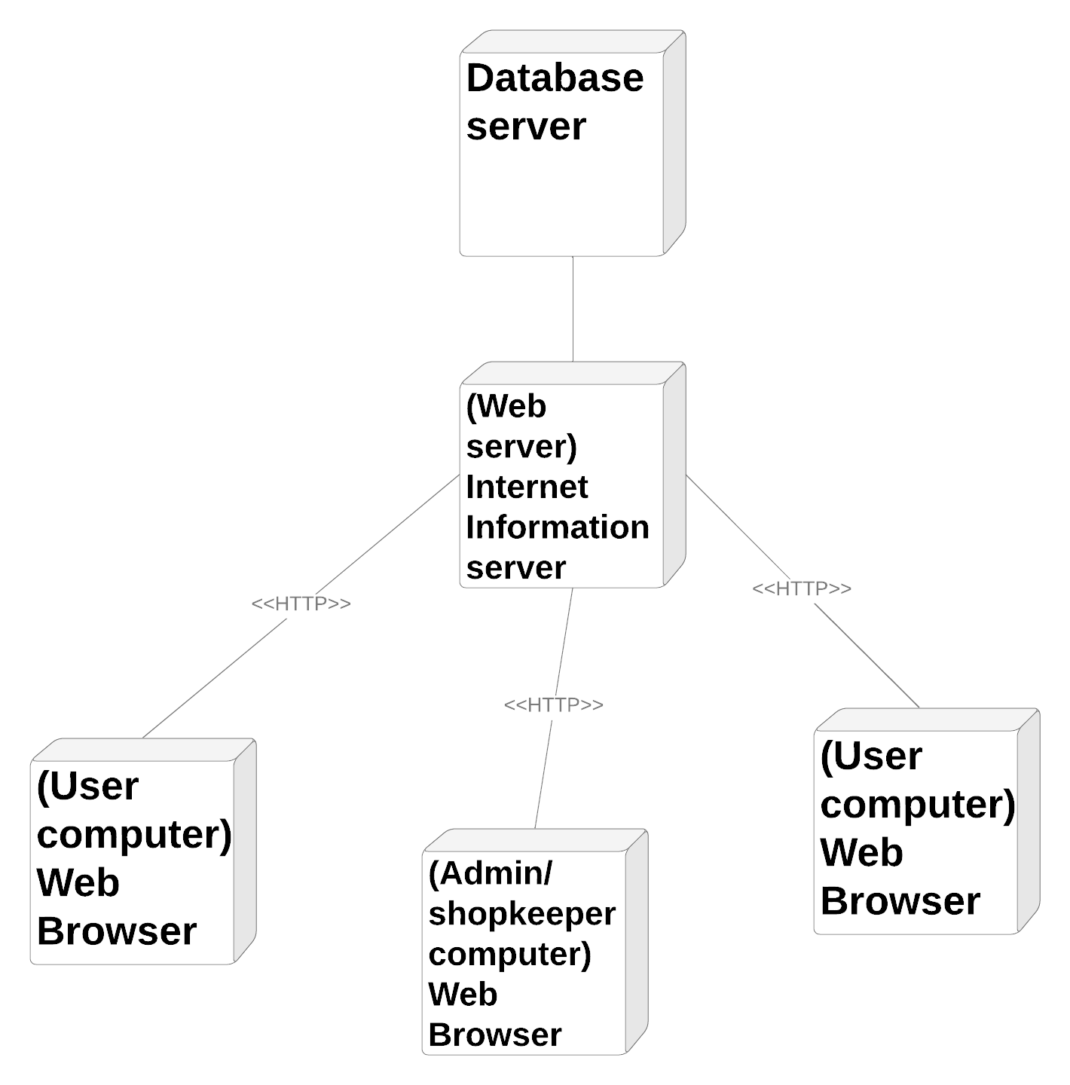

# **Data Dictionary**

1. Customer Table 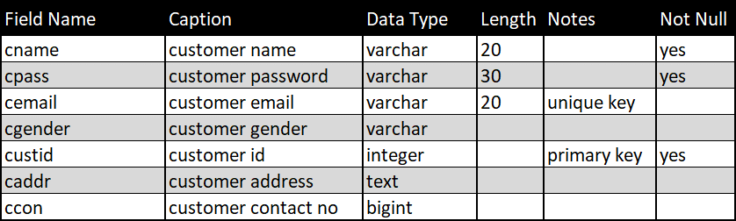
2. Product Table 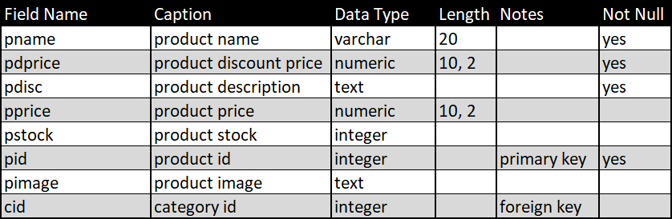
3. Category Table 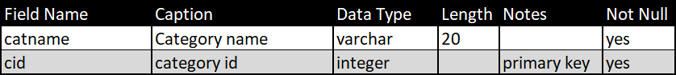
4. Cart Table 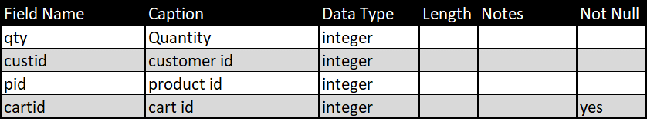
5. Feedback Table 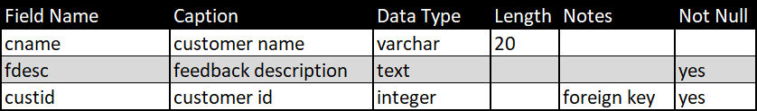
6. Admin Table 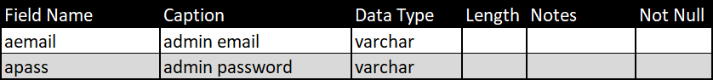

# **Conclusion**

* Human errors are reduced.
* Data storage is done efficiently.
* Data retrieval is faster.
* Keeping a record of all entered was a very tedious job.
* Searching a particular entry was tedious because it involved searching all entries which required more time.
* The cost for maintenance is eliminated.
* Makes system user friendly.
* Our system provides two types of user administrator and local user which have a limited functionality. It improves the security.
* Only the users who have administrative rights are allowed to create or modify users and unlock/lock users.

# **Advantages**

* It is fast, efficient and reliable.
* Avoids data redundancy and inconsistency.
* Very user friendly.
* Easy accessibility of data.
* Number of personal required is considerably less.
* Provides more security and integrity to data.
* Helps Bakery shops to automate bakery selling online.
* Helps Bakery shops to take cc payments.
* Provides email confirmation on payment success.

# **Disadvantages**

* Requires training for the operator to maintain and look for statistical data.
* Requires customer to have basic internet knowledge.

# **Applications**

* This system can be used in single Bakery shops.
* This system can be used to sell like chain of Bakery shops from a single site.

# **Bibliography**



1. <http://www.google.com>
2. C# 2010 Programming Black Book Covers .NET 4.0
3. http://www.wikepedia.com